Transaction Manager

🔄 What Is a Transaction Manager in a DBMS?
# Source: AI Source: Provided by: [Data Path: Persons Table -> ID Column: 1, Name_En Column: Motasem Essam] -> From: [ChatGPT] on [6/10/2026]
The Transaction Manager is a critical component of a Database Management System (DBMS) that ensures reliable, consistent, and safe execution of transactions — especially when multiple users or operations access the database at the same time.
It enforces the famous ACID properties of transactions:
Atomicity, Consistency, Isolation, Durability

🧩 What Is a Transaction?
# Source: AI Source: Provided by: [Data Path: Persons Table -> ID Column: 1, Name_En Column: Motasem Essam] -> From: [ChatGPT] on [6/10/2026]
A transaction is a sequence of database operations that are treated as a single logical unit of work.
Example:
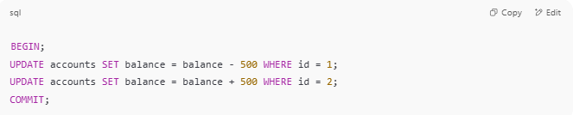
BEGIN;
UPDATE accounts SET balance = balance - 500 WHERE id = 1;
UPDATE accounts SET balance = balance + 500 WHERE id = 2;
COMMIT;

This must either:
- Complete fully (COMMIT)
- Or be rolled back if there's an error (ROLLBACK)

🧠 Responsibilities of the Transaction Manager
# Source: AI Source: Provided by: [Data Path: Persons Table -> ID Column: 1, Name_En Column: Motasem Essam] -> From: [ChatGPT] on [6/10/2026]
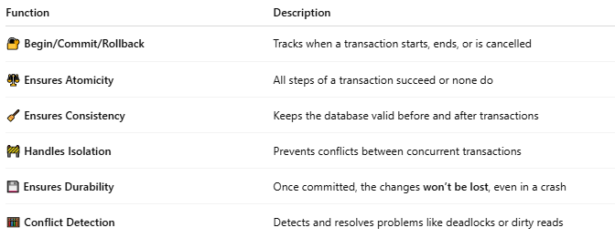
Function | Description
🔐 Begin/Commit/Rollback | Tracks when a transaction starts, ends, or is cancelled
⚖️ Ensures Atomicity | All steps of a transaction succeed or none do
🧹 Ensures Consistency | Keeps the database valid before and after transactions
🚧 Handles Isolation | Prevents conflicts between concurrent transactions
💾 Ensures Durability | Once committed, the changes won’t be lost, even in a crash
🧮 Conflict Detection | Detects and resolves problems like deadlocks or dirty reads

🔄 ACID Properties Explained
# Source: AI Source: Provided by: [Data Path: Persons Table -> ID Column: 1, Name_En Column: Motasem Essam] -> From: [ChatGPT] on [6/10/2026]
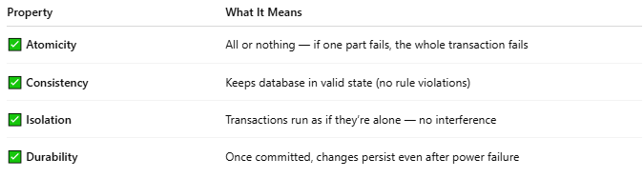
Property | What It Means
✅ Atomicity | All or nothing — if one part fails, the whole transaction fails
✅ Consistency | Keeps database in valid state (no rule violations)
✅ Isolation | Transactions run as if they’re alone — no interference
✅ Durability | Once committed, changes persist even after power failure

🗂️ Real-World Scenarios
# Source: AI Source: Provided by: [Data Path: Persons Table -> ID Column: 1, Name_En Column: Motasem Essam] -> From: [ChatGPT] on [6/10/2026]
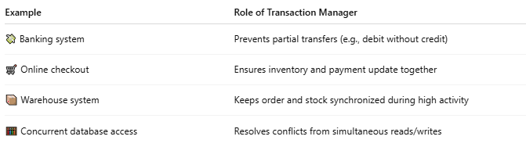
Example | Role of Transaction Manager
💸 Banking system | Prevents partial transfers (e.g., debit without credit)
🛒 Online checkout | Ensures inventory and payment update together
📦 Warehouse system | Keeps order and stock synchronized during high activity
🧮 Concurrent database access | Resolves conflicts from simultaneous reads/writes

🛠️ Behind the Scenes
# Source: AI Source: Provided by: [Data Path: Persons Table -> ID Column: 1, Name_En Column: Motasem Essam] -> From: [ChatGPT] on [6/10/2026]
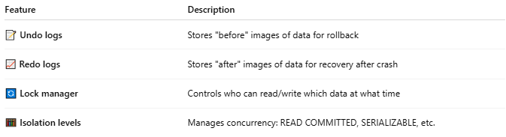
Feature | Description
📝 Undo logs | Stores "before" images of data for rollback
📈 Redo logs | Stores "after" images of data for recovery after crash
🔄 Lock manager | Controls who can read/write which data at what time
🧮 Isolation levels | Manages concurrency: READ COMMITTED, SERIALIZABLE, etc.

🔧 In Popular DBMSs
# Source: AI Source: Provided by: [Data Path: Persons Table -> ID Column: 1, Name_En Column: Motasem Essam] -> From: [ChatGPT] on [6/10/2026]
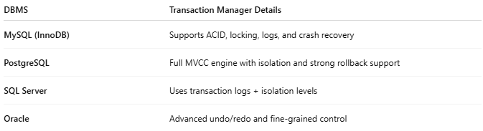
DBMS | Transaction Manager Details
MySQL (InnoDB) | Supports ACID, locking, logs, and crash recovery
PostgreSQL | Full MVCC engine with isolation and strong rollback support
SQL Server | Uses transaction logs + isolation levels
Oracle | Advanced undo/redo and fine-grained control

📌 Summary
# Source: AI Source: Provided by: [Data Path: Persons Table -> ID Column: 1, Name_En Column: Motasem Essam] -> From: [ChatGPT] on [6/10/2026]
The Transaction Manager ensures that database operations are safe, reliable, and isolated, following ACID rules. It’s vital for data integrity, especially when errors, crashes, or multiple users are involved.

